|  |
| --- |
| Project Report  Artificial Intelligence in the context of our daily lifes |
| ***Adam Fager, Patrick Hildenbrand, Theresa Moessmer***  RMIT Vietnam 15.01.2023  Saigon South Campus  Vietnam  RMIT  Saigon South Campus  Vietnam  RMIT  Saigon South Campus  Vietnam |



Content

1. Background & Motivation 3

2. Team Profile 3

3. Tools 5

4. Project Description 5

5. Project Management 13

6. Project Outcomes 17

7. Group Reflection 19

8. Literature list 21

Artificial intelligence – how does it affect our daily lives

# Background & Motivation

Artificial intelligence is a topic that is increasingly becoming the focus of research and business. The reason for this is not least the enormous potential of artificial intelligence. Furthermore, Artificial intelligence (AI) is already impacting many areas of our lives. In the future, this key technology will gain in importance and the expectations associated with AI are already very high. Almost all market research institutes see great potential and growth opportunities for AI technologies. It is therefore not surprising that many stakeholders are closely monitoring the latest developments in the AI market as well as wanting to share in the potential successes. The potentials of AI are almost limitless and can solve problems in society as well as in the economy. For example, AI is already achieving impressive results in the field of medical diagnostics and is leading to economic growth in industry through more efficient processes. But AI also helps in science, for example in the analysis of large volumes of research data, and thus accelerates processes.[1]

Despite these enormous potentials, A 2022 Pew Research survey found that 37 percent of respondents who are more concerned than excited about AI. Concerns about job loss came up, as well as concerns about privacy and the potential for AI to "outperform human capabilities.".[2] It is obvious that AI is an increasingly large and very complex topic, which sparks a lot of controversial discussions. This is exactly why it is important to acquire the basic knowledge of this subject. That is why we have decided to dedicate our assignment to this topic.

# Team Profile

#### 2.1 Team name

Our company’s name is **„MatchIg – The Match-it-Magic“.** Since it is matching your movie and series interests in a magical way.

2.2 Personal Information

Rightnow our Team has three members. Those are:

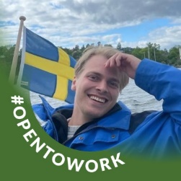**Adam Fager:**

Adam is our IT expert, from all team members he has the most experience with IT and programming. His reliable and funny nature makes working with him very easy and pleasant

**Career plans:** “Having studied a Bachelors in Business Administration with a focus on management control and currently in a Master of IT and Management I feel I have gotten a good plan of my career options. My wish is to help the change for the IT-field to be more efficient, less vulnerable to mistakes, especially in IT-projects and be a part of the new management within this fast-growing field. My wish is to help organizations understand the impact between tech, society and organization, as well as the importance of understanding the connections between them. A field I strive for to get in to is the cloud technology field and help be a part of the evolution of it.

**Partick Hildenbrand**

Ein Bild, das Person, Wand, Mann, Kleidung enthält.
Patrick is very experienced when it comes to project implementation and execution. He keeps track of time and coordinates the project so that everything is done on time. His kind and calming nature have a positive effect on the team.

**Career plans:** “Since I started my career in engineering at a manufacturer of construction machinery in 2015, my interests go into several other areas like business, information systems and digitalization. Therefore, I wanted to go in an area where I have a lot of different tasks todo each day – and ended up in as a Product Manager.

Nevertheless, I recognized, that I wanted to go more into the direction of IT, that’s why I started 2020 my masters as MBA Digital Innovation. Since I see there increasing interests, I also want to go more into IT in my business career, therefore I am looking for the next job step. Like for example going into the Product Management of Digital Products or even IT solutions.”

**Theresa Moessmer**

She is the creative part of our group and responsible for the ideas and their execution. She finds solutions quickly and has a practical way of approaching things.

**Career plans:** “Since I started my career in engineering at a manufacturer of construction machinery in 2016, called Putzmeister. Since it is a international company deeply connected to China, my interests in intercultural working areas came up. I continued study international management in my masters degree and during this time my interest in information technology came up. Now I am continuously improving my IT specific skillset in the hope for work in an international tech company as a project manager.”

|  |  |  |  |  |
| --- | --- | --- | --- | --- |
| Name | Student ID | E- Mail | Nationality | Major Subject |
| Adam Fager | 3978451 | s3978451@rmit.edu.vn | Swedish | Master’s in IT & Management |
| Patick Hildenbrand | 3978860 | s3978860@rmit.edu.vn | German | MBA – Digital Innovation |
| Theresa Moessmer | 3978902 | s3978902@rmit.edu.v | German | M.A. Internat. Management- Asia Europe |

2.3 Group Processes **=> ADAM**

The group worked well in the assignment and there were clear goals for each member to contribute to the result. The purpose of the project was well sorted to each member to make it easy for everyone to understand what is sought after. Seeing as each member has different experiences and study backgrounds made the project work interesting and helped add new perspectives. This can be in contrast with how project work can look like in an organization where people from different departments work on the same project. It’s a valuable experience and helps bring new perspectives to everyone that’s a part of it. Having this type of set up also makes preparations for us in our future work.

# Tools

**Chapter: Git Hub ==> ADAM**

1. **Create a Team Website on Git Hub**
2. **Setup a HTML Webpage with the Content from our Report**
3. 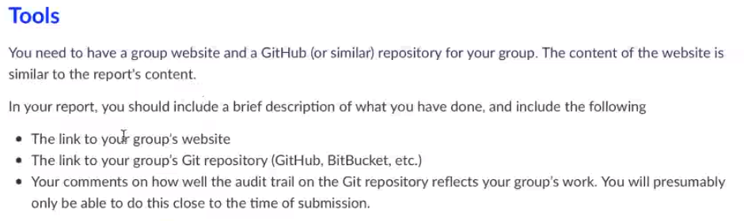

#### 3.1 Git Hub

Tbd

#### 3.2 HTML-Webpage

Tbd

# Project Description

#### 4.1 Critical Context analysis

Worldwide developments such as globalization and increasing urbanization will push living spaces Nowadays artificial intelligence (AI) is a very trendy word, which impact has not only increased in the research areas but also in the application fields during the past several decades.[3] As the following figure number one shows, the impact on the application areas is rapidly accelerating the world economy.

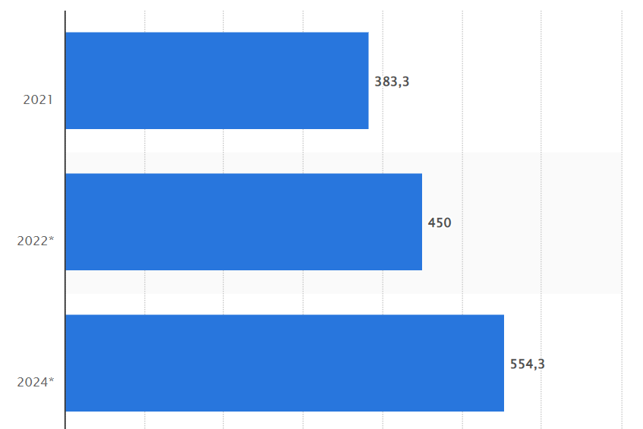

***Figure 1: The world’s sales in the area of artificial intelligence in M€***   
***by the German authorities for statistics 2021[4]***

Artificial intelligence (AI) describes a broad area of computer science that makes machines work like human brains.[5] The aim of AI is to facilitate systems with intelligence that is capable of humanlike learning and reasoning. Which makes it successfully implementable for numerous industrial areas, including image classification, speech recognition, autonomous cars and computer vision.[6]

In 1956 John McCarthy discovered the first form of AI, but he failed to achieve its objectives, due the lack of technologic innovations. Afterwards in till the 1970s, several researchers explored AI through the Knowledge-based systems (KBS) and Artificial-Neural-Networks (ANN):[7]

* **The KBS systems:**  
  KBS systems are computers that provide advice using pre-determined rules, according to the knowledge presented to it by humans.[8]
* **The ANNs:**  
  These neuronal computational modelling tools have recently emerged and found extensive acceptance in many disciplines for modelling complex real-world problems.[9] Inspired from biological nervous systems and brain structure, they are designed in various layers, modelled after the human brain.[10] Thanks to this structure, ANN use learning and generalization capabilities and are very adaptive. As a result of their high adaptability, can be seen as powerful solutions for subjective information processing, decision-making, forecasting and related problems the real-world and industrial applications.[11]

In the next decades, the interest diminished due to limited applications and the lack of data until the 1980s. But since then, much research was conducted to minimize the error of prediction. Therefore, they used a method, which is referred to a Backpropagation algorithm for the training of the ANNs. But talking about today, the availability of data has introduced the concept of machine learning as a subcategory to AI:[12]

* **Machine learning (ML):**  
  Machine learning (ML) is a form of artificial intelligence which is placed to transform the twenty-first century.[13] ML includes the human brain behaviour, but instead of teaching the brain it just implies the behaviour to learn something themselves. Therefore, ML provides the computers with access to big data and extract important features to solve problems.[14]

Meanwhile, the rapid development of data science, including sensor technology, Internet-of-Things (IoT), edge computing, digital twin, and big data analytics, provides a wide variety of data. The increasing volume of data enables immense opportunities and lays a solid foundation for the AI analysis.[15] Thus in the following part some applications shall be executed exemplarily in their application:

* **Autonomous Vehicles: [16]**  
  One of the most popular examples of AI in the real-world are the autonomous car. Thanks to the fueling by big data in form of sensing devices, AI has become the key component of self-driven cars, which can perceive the surrounding environment and making appropriate decisions. To achieve the goal of 100% automation, it is important to know how AI works in autonomous vehicle systems. Therefore, the three dimensions perception, localization and decision-making are under research.
* **Transport: [17]**  
  The transportation industry is challenged by a lot of trends like globalization, urbanization and sustainability, which make the whole travel patterns difficult to predict. Therefore, AI could be the solution to address and predict the challenges of increasing travel demand, CO2 emissions, safety concerns, and environmental degradation.
* **Finance: [18]**  
  Even in the financial segments AI can make its way to predict the future: As a financial market can be categorized with the three techniques: credit evaluation, portfolio management and financial prediction and planning. To put it in a nutshell, the study results show that accuracy of AI methods is more accurate than the traditional statistical methods in dealing with financial problems.
* **Care and Medicine: [19]**  
   A variety of new AI tools have also made their way into the care environment and become available as intelligent assistants to clinicians, constantly monitoring electronic data streams for important trends, or adjusting the settings of bedside devices. But as well for new challenges like the pandemic of COVID-19, AI helped in terms of drug discovery and development, diagnosis and clinical outcome prediction and epidemiology[20]

#### 4.2 Transiation to the Subject

Since AI is a very complex topic bus still already integrated into our daily lives without us being aware of it, we set ourselves the goal of creating a product/ service that makes the whole topic of AI tangible for all of us.

Thereby we have a problem to help us, which in our opinion should be solved for a long time already. This Problem is the endless discussion about what movie or series you and your family, friends or partner are going to watch this evening.

AI in the landscape of entertainment and especially in terms of movie providers is nothing new. The big players like Netflix are already adapting the recommended movies according to your preferences by analysing the user behaviour in the app. But at the same time, it is not possible to share or even compare the user behaviour to other users (your friends). Therefore, our idea is to include a new app which makes it possible to compare your interests with friends and get recommendations for possible films, series & more to watch together. Basically, this is the approach of another important landscape: the dating platforms. Here Tinder & Co. Match not movies but people together – but we will do the other way around: we connect people by matching movies.

#### 4.3 Target, Scope & Limitations

The following project will be specified by the SMART-technique to define targets. SMART is a criterion for the clear formulation of measurable and verifiable goals. The concept goes back to the management researcher and management consultant Peter Drucker. In this concept every letter of the word “smart” is an acronym for one dimension to specify the target (Doran, 1981):

**S(pecific)**

The target of the project is to choose a contemporary technology and describe the effects on our modern world. For our project we will pick up the topic of Artificial Intelligence (AI) and therefore identify a possible use case for this emerging technology. As part of the entertainment industry, we as “MatchIg” want to contribute with AI to make the movie nights with family or friends more satisfying to all participants. Hence, we will introduce a application, which will match the different interests of consumers together, based on the similarities of watching movies, series, TV shows or documentaries. At the end of the movie night, all participants will be happy, due to an easy selection and matching process.

**M(eassurable)**

As a project outcome we will set up a report about the process from defining contemporary technology, its usage, its application fields, it’s changed in the new digital world and build up a first prototype solution (Minimum Viable Product) for that. In Addition, there will be a pitch presentation, to make the topic comprehensible within about ten minutes of presentation.

**A(cceptable)**

Furthermore, the target should be acceptable to the rules and conditions of the RMIT Vietnam. Additionally, we have the personal targets to learn a little bit more about the buzzword AI and understand more about the exciting technology and its chances for our human life.

**R(ealisitic)**

It is not realistic to introduce a real application based on AI technology and make it accessible on the App store. For that we are not skilled enough in programming an app and to set up the artificial intelligence.

Thus, we will use our IT skills to make a first prototype or MVP (minimum valuable product), which can be used as a proof of concept for AI-technologies in our modern world. Therefore, it is mandatory to set up a prototype like a user-interface-design, a Business Model Canvas or a paper prototype to get into the discussion with potential customers. Very important in this context is to ensure a agile and customer-centric feedback process, which makes sure that the customer feedback and needs will be implemented in the project.

**T(imed)**

The time target of 6 weeks will be applied for this project, with the pitch presentation on 11th and the final report on 15th January 2023.

#### 4.4 Problem-Solution Fit

The Problem-Solution-Fit and the resulting Product will be described by the following paragraphs and the attached figure. 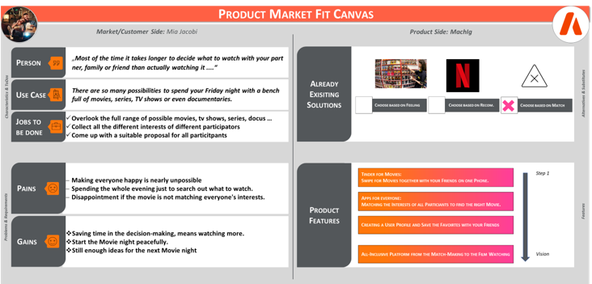

Figure 1: Product-Market-Fit of our AI-solution

**Describing the Problem statement:** “*There are so many possibilities to spend your Friday night with a bench full of movies, series, TV shows or even documentaries. Most of the time it takes longer to decide what to watch with your partner, family or friend than actually watching it ...“*

**Describing the Jobs-to-be-done:**

* Overlook the full range of possible movies, tv shows, series, docus …
* Collect all the different interests of different participators
* Come up with a suitable proposal for all particitpants

**Describing the Product Features:**

* App accessible for everyone in the App stores
* Matching the Interests of all Particiants to find the right Movie.
* Creating a User Profile and Save the Favoirtes with your Friends
* Swipe for Movies together with your Friends on one Phone.

**è Tinder for Movies**

#### 4.5 Tools & Technologies

The following paragraph will summarize the tools, which have been used to support the team within the project progress. Most of the tools are quite basic, but very useful to structure the most-likely creative project progress and ensure that the target scope is always the purpose of all activities.

* Communication & Sharing of Data: MS Teams  
  Since the Covid19-pandemic we got all used to MS Teams and are very familiar with some special features.
* Documents: MS Word and MS Powerpoint  
  The daily work in school and business is not possible without MS office, therefore everyone should be used to it.
* Brainstorming: Miro Whiteboard  
  Miro Whiteboards have proven themselves to be a suitable solution to execute online workshops and still document every outcome together with the participants.
* App-Scribbles: Paper and Pen  
  The traditional way of generating scribbles is maybe something new for some of us, but it is the most effective way to share brainstorming ideas pretty fast with others and keep on working on these ideas.
* MVP / Prototype: Wireframe.com

Wireframe.com is a useful platform to generate mock-ups for different applications like smartphone apps. It is a fast way to generate a MVP out of some slides and show it to customers. Therefore, it represents a useful tool in the customer discovery process.

* Programming Tool: Visual Basic or Phyton PyCharm

Only after finishing the MVP-status we want to go further to the next status: the programming of the App. This is maybe the only part where we are not that far skilled. We are right now enrolled in the bachelor course at RMIT “Introduction to Programming”, where we are learning the basics of the programming language “Phyton”.

#### 4.6 Prototype Testing

According to Dorf et al. (2014), it is crucial to integrate customers throughout the entire development and implementation process to ensure the product-market-fit. The "customer discovery" process according to Dorf et al. (2014) can be a helpful approach here in order to identify the weak points and make the final adjustments before it is finally launched on the market. For this reason, the literature recommends identifying so-called "early adopters" or also "pioneer customers" who buy and test the products because they want to be the first. With the correct selection and continuous integration of these customers, a suitable value proposition can be derived and tested iteratively:[21]

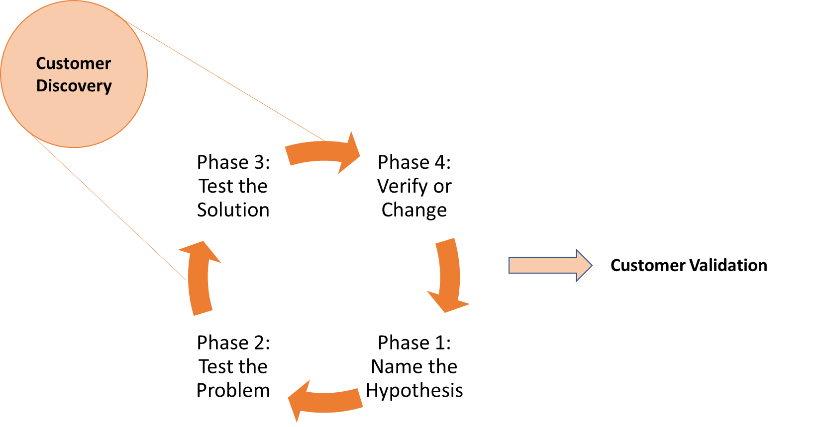

Figure 2: The Customer Discovery Process **[22]**

**1st phase: Identification of the customers and their problems[23]**

Question: "Who are the "early adopters" for the topic "AI-Matching for Movies"? "Tool: Customer Value Proposition (as part of the initiation phase) Content: Definition of the customer group and the "Customer Pain and Gain Points".

**2nd phase: formulation of the hypotheses**

Hypothesis: "Personas in question are those who have movie nights together with several other personas and are looking for a quick and fair solution to choose from."

Tool: business model canvas Content: define the business model idea to solve the customer problems.

**3rd phase: Testing the problem**

Testing: "Unfair and slow selection and decision-making processes."

Tool: semi-structured customer interviews Content: query and validation of the created hypotheses of the Business Model Canvas

**4th phase: testing the solution**

Testing: "Mockup of the MatchIg Business Model"

Tool: Development of a prototype (in the first step per Business Model Canvas, afterwards also prototype tests with the help of screen designs)

**5th phase: Verification or adaptation**

Depending on the result, this is followed by the implementation of the business model or a loop with a new start at phase one.[24]

# Project Management

#### 5.1 Plans & Progress

The following time plan is based on the different working packages from CL01-CL06 and starting from CW45 2022 till CW2 in 2023.

|  |  |  |
| --- | --- | --- |
| CL | Week | Activities |
| 01 | 45/46 | Get into the topic. Researching and analysing the current state of the technology. And define the project proposal. |
| 02 | 47/48 | Analysing the human and social contexts of the new technology. Research into possible application fields like smartphone apps but also self-driven cars. |
| 03 | 48/49/50 | Apply the collected knowledge about application fields and adopt it to the own project: brainstorm different ideas and build up a prototype solution (MVP) |
| 04 | 50 | Brainstorming on principles of collaborative work and explain potential conflicts within the application fields |
| 05 | 51 | participation in a team environment |
| 06 | 52 | Preparation of the professional and comprehensively written IT report and the final presentation |

This project involved a team of 3 members who met on a weekly basis to discuss progress and address any issues that arose. Despite some challenges, we were able to stay on track with our time plan and achieve our objectives.

Through our efforts, we were able to accomplish our weekly goals. In summary, our project was a success. We were able to meet our objectives and make a positive impact. Our team worked effectively together, and we were able to stay on schedule despite some challenges. We learned a lot through this process and believe that the lessons learned will be valuable for future projects.

#### 5.2 Risks

**Chapter: Risks ==> ADAM**

1. Risiks
   * Reflect on the risks we had identified in the project proposal

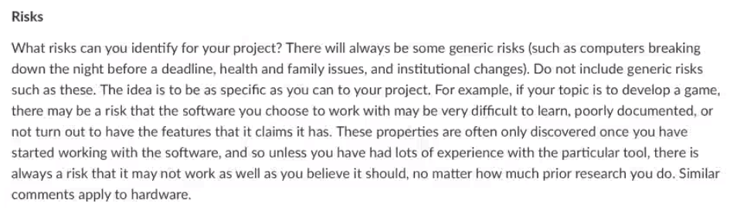

The first risk in mind for this project are uncertain factors that can affect the efficiency of the project work. Planning in our case is key as we are studying different courses and therefore our schedules differ. In more specific details the risks of our projects are based of similar research based on the topic at hand. Artificial intelligence is an up and coming subject and different authors have varied opinions about its future. Risk to bear in mind can be empirical or technical implications of the product at hand. How is it actions can bring more risk than benefit and which areas can be affected by it. To best prepare for this is to make sure that good research is considered and assess the positive and negative aspects. Diving into similar projects and their result can be a start to get a grip on what risks they had and if it is similar. As the program that is proposed for this project uses input data to evaluate search results it bases on behaviour patterns which in turn can come with ethical issues.

The risks of AI and ethics

 The increased awareness of AI and its implications to ethics comes the rise of cases where misuse of AI have led to damages to society. AI ethics have emerged to help deal with the consequences that development from AI have on our society and the people in it. It helps to understand and prevent decision making that can have harmful results by helping the program to abide by our ethical standards. Below are some common issues that developers need to have in mind to help abide by ethical standards.[25]

Bias and discrimination are a major problem with using AI as it is based on input from a human perspective. This can in turn lead to data that are from human’s view of society, this can be for example discrimination against colour, jobs, inequality. This can cause the AI to analyse data in a way that promotes bias and makes the program act different depending on the user. The reason being that the data is received already has problems from the beginning. [26]

Lack of transparency in a program is another issue where minimal insight to an AIs decision making can result in increased inequality in its decision making. Without transparency in an AI program there is less trust for users to be comfortable in using the program and it led to increased distrust down the line. Therefore, transparency is a central part of most organizations AI policy and something that most governments emphasise regulations in. Transparency in AI means a program that has qualities to be seen through, inspected, explained, and not have secrets. A person should be able to understand why an AI has made a certain decision and be able to trace it back to its source.[27]

An AI can also be intrusive towards a user’s privacy, letting AI as a base for security concerns is that information can be leaked from improper AI design. However, this can be like human mistakes in security flaws but in contrast to human design. The security flaws that can be generated from AI can be harder to pinpoint and correct.24

To combat these issues, it is important for the project to apply good ethical guidelines in the use and development of AI. Having set out response instructions if any of these concerns may arise and setting standards for what AI should be used for. It is also important for not just organizations but statewide regulations to ensure that some companies do not take advantage of these issues for potential gain. When using AI, it should be used to expand human decision making and not a means to replace it. 24

The technical risks of this project being AI based is that the AI may pose challenges in showing the right results for the user based on their preferences. As a risk can be that the AI behaves in uncertain ways. A result can be movies that show the users that are not suitable and can even be harmful for the user to watch. For example, a movie that is psychologically difficult for that person to watch. It is important to know the outcomes of these risk and be prepared to prevent them if they arise.2 Humans interacting with AI can sometimes leads to results which are not planned for, The results may lead the AI to perform tasks with lack of transparency, bias results and further ethical issues

#### 5.3 Group Communication

**Chapter: Group communication**

Reflect on the group communication **==> ADAM**

1. 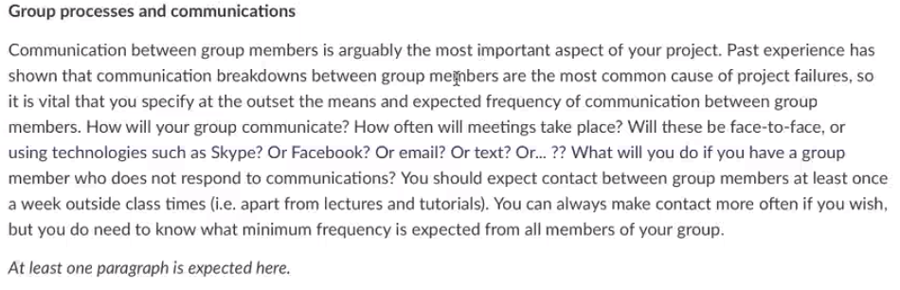Communication in this group project will primarily consist of meetings during weekdays, working together on the report and sharing ideas. Digital communication consists of a WhatsApp group that has been created but also through teams and video meetings. Depending on the week of the project communications can be varied. Expectations of this group project have been set out and each member needs to contribute to equal terms. A group contract has not been set out in this case as the terms of equal contribution and responsiveness have to this point good. However, this is a good option if someone in the group is nonresponsive to communication and does not show the same efforts. The first step for us if a problem occurs with a member of the group is to confront the action and why it may not be beneficial for the result. The reason for this is to minimize the risk of long-term failures and increase the chance for project success. AI and communication are a wide field and can be interpreted from many different perspectives. It can be communication via the help of AI for example the AI use in social media, machine learning from different inputs by a user, using AI to generate better results and communicating through AI based hardware like Google home. AI can also be used to better communicate with other devices like in telecommunication. However, in this report it will tie to the use of AI to generate better input results from the communication the users have and how the AI learn from it. In a sense the AI uses the communication of data from user input, patterns, and behaviours in a program to list relevant searches for the user of a program. [28]

# Project Outcomes

#### 6.1 Product Description

Now, of course, the question is how AI should solve this problem for you. Well, that’s easy. With the help of the app, we are going to develop for you. All you need to do is create an account. Answer a few questions about your personal movie preferences and create groups. For example, one group with your family, one group with your friend or even a whole friend group and one more group with your boyfriend or girlfriend. The basic condition is that all target users use the app. After all of you answered the basic question of your movie or series preferences, you are going to get several movie/ series proposals, which you can swipe right if you like it or left if you don’t. This process is usually known from tinder.

After a wile of swiping an overlap of films and series that you swiped right as well as other group members did an on this way there is going to be a growing list of movies, you and all the other team members like to watch. So, for every group you create there will be the perfect list with movies and series you could watch together.

AI is doing its part in the background. Based on your preferences it will propose your movies to swipe and based on what you swiped right and left it is improving the selection of movies and series presented to you.

Another very useful tool of our app is, that you can also choose the streaming providers at the beginning so you will only find available movies and series on your lists.

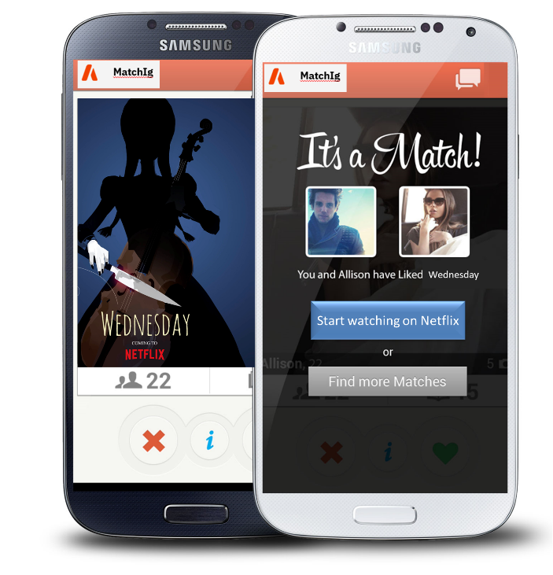

Figure 3: Prototype

Right now, we finished the requirement list, as well as the prototype. That’s why we can start developing the app in an next step. Therefore, we need to extend our team, since we need specific programming skillsets, which we do no have. As well as we need a marketing expert, in a next step to promote our new app.

#### 6.2 Skills & Jobs

To create a successful Team working on our app, we need following positions:

• App Developer

• Project Manager

• Social Media Marketing Manager

The position of an app developer at our company involves creating innovative mobile applications for both iOS and Android platforms. The successful candidate will have a strong understanding of programming languages such as Java and Swift, as well as a passion for staying up-to-date on the latest app development trends and technologies.

In this role, you will be responsible for the full life cycle of app development, from conceptualization to deployment. This includes working closely with a cross-functional team of designers, project managers, and QA testers to ensure the successful delivery of high-quality applications. You should be able to work well in a team environment and be able to contribute creative ideas and solutions to complex problems. The ideal candidate will have a proven track record of successful app development projects, as well as a strong portfolio showcasing their work. We are looking for someone who is highly innovative and able to think outside the box in order to develop unique and engaging apps for our users. If you have a passion for app development and enjoy working in a fast-paced, collaborative environment, we encourage you to apply for this exciting opportunity.

The position of Project Manager for the development of a new app at our company involves overseeing the entire app development process from start to finish. The successful candidate will have a strong understanding of the app development process and a proven track record of successfully delivering complex projects on time and within budget.

In this role, you will be responsible for managing a team of developers, designers, and QA testers to ensure the successful delivery of the app. You will be responsible for creating project plans, assigning tasks, tracking progress, and communicating with stakeholders to ensure the project is completed according to schedule. You should be able to work well in a team environment and be able to motivate and lead your team to achieve project goals.

The ideal candidate will have excellent communication and leadership skills, as well as the ability to think outside the box and come up with creative solutions to complex problems. You should also be highly organized and able to manage multiple tasks and projects at once

The position of Social Media Manager at our company involves developing and implementing innovative social media strategies for a new mobile app. The successful candidate will have a strong understanding of social media platforms and a proven track record of growing online communities.

In this role, you will be responsible for managing the company's social media accounts, including Facebook, Instagram, Twitter, and LinkedIn. You will be responsible for creating engaging content, interacting with users, and analyzing social media metrics to determine the success of your campaigns. You should be able to work well in a team environment and be able to collaborate with designers, developers, and other team members to ensure the success of our social media efforts.

# Group Reflection

**Chapter Group reflection**

1. Each member has to write a reflection on the whole project **==> EVERYBODY**

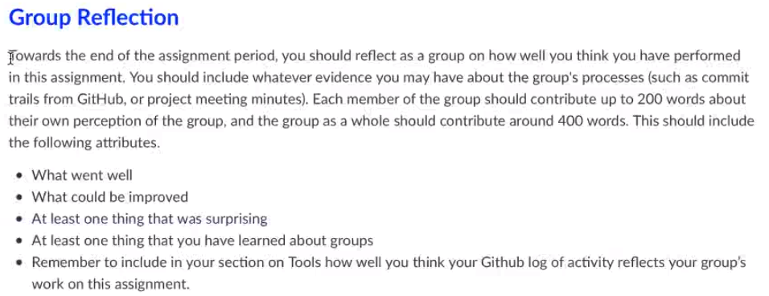

**Theresa:**

As a team member, I have experienced the benefits of good teamwork firsthand. When I am part of a team that communicates effectively, trusts one another, respects each other's ideas and contributions, and collaborates towards a common goal, we are able to accomplish so much more than we could individually.

For example, I remember being part of a team that was working on a project with a tight deadline. We were able to complete the project on time and exceed expectations because we all worked together, shared our ideas and expertise, and supported each other throughout the process. It was a great feeling to know that we were able to achieve such success because of our teamwork.

**Patrick:**

In the following part I want to reflect on the last 10 weeks about our group project Therefore, first I want to thank you the team, as the project turns out it feels like colleagues become to friends. This is I guess also the most important factor by working in teams, you should always feel psychological safety and feel free to share your ideas, no matter how crazy they look in a first way. As it turns out, our crazy idea “Tinder for Movies” may have a real impact, as there are personas and potential customers looking for pain relievers to their need.

Therefore, I guess it would be great to continue the work together. As we also learned our lessons how to work in a project together via different online tools like MS teams, Miro and even our new area of programming with Python. In a next Project step, I want to get the focus of the project more into the customer perspective. Hence, we should go out to potential customers and pitch our idea, but as well the first prototype to them, to get real feedback and launch the next steps of our product development and business plan.

To sum it up, I liked the whole project at the RMIT as it was an open topic to search in the faster developing area of IT solutions. Furthermore, it was another eye-opener for me, that IT is the future in our life and probably will also be in my career plans.

**Adam:**

As a team member,

It has been exciting to write about a field im passionate about, the AI field. To further implement from my own experiences and what ive learnt in my previous studies. Seeing as AI has had a enormous impact on businesses the last few years and that it will continue to do so. Having a project like this to further explore the AI field it exciting. AI has greatly shown to make it easier for organisations to further understand user behaviour than before and is only continuing to grow.It makes for better decision making for businesses and consumers. It was this experience for us that helped set out the subject of the project and our own thoughts about the difficulties we have had to pick movies.

The team have had a clear mindset about what it is that we are doing for this project, and I think this has made the work efficient and helped add to it being interesting to write about.

# Literature list

ABDULJABBAR, RUSUL, ET AL. APPLICATIONS OF ARTIFICIAL INTELLIGENCE IN TRANSPORT: AN OVERVIEW. *SUSTAINABILITY*, 2019, 11. JG., NR. 1, S. 189.

BAHRAMMIRZAEE, ARASH. A COMPARATIVE SURVEY OF ARTIFICIAL INTELLIGENCE APPLICATIONS IN FINANCE: ARTIFICIAL NEURAL NETWORKS, EXPERT SYSTEM AND HYBRID INTELLIGENT SYSTEMS. *NEURAL COMPUTING AND APPLICATIONS*, 2010, 19. JG., NR. 8, S. 1165-1195.

Cath, C. (2018). Governing artificial intelligence: ethical, legal and technical opportunities and challenges. *Philosophical Transactions of the Royal Society A: Mathematical, Physical and Engineering Sciences*, *376*(2133), 20180080.

Guzman, A. L., & Lewis, S. C. (2020). Artificial intelligence and communication: A Human–Machine Communication research agenda. *New Media & Society*, *22*(1), 70-86.

HANSON III, C. WILLIAM; MARSHALL, BRYAN E. ARTIFICIAL INTELLIGENCE APPLICATIONS IN THE INTENSIVE CARE UNIT. *CRITICAL CARE MEDICINE*, 2001, 29. JG., NR. 2, S. 427-435.

Leslie, D. (2019). Understanding artificial intelligence ethics and safety: A guide for the responsible design and implementation of AI systems in the public sector. The Alan Turing Institute. https://doi.org/10.5281/zenodo.3240529

NICHOLS, JAMES A.; HERBERT CHAN, HSIEN W.; BAKER, MATTHEW AB. MACHINE LEARNING: APPLICATIONS OF ARTIFICIAL INTELLIGENCE TO IMAGING AND DIAGNOSIS. *BIOPHYSICAL REVIEWS*, 2019, 11. JG., NR. 1, S. 111-118.

Statista Research Department. (2022, 09 15). *Statista*. Retrieved from https://de.statista.com/themen/9874/ki-weltweit/#topicHeader__wrapper

Rainie, L., Funk, C., Anderson, M., & Tyson, A. (2022). *AI and Human Enhancement: Americans’ Openness Is Tempered by a Range .* Washington: Pew Research Center.

YIFANG MA, ZHENYU WANG, HONG YANG AND LIN YANG, "ARTIFICIAL INTELLIGENCE APPLICATIONS IN THE DEVELOPMENT OF AUTONOMOUS VEHICLES: A SURVEY," *IEEE/CAA J. AUTOM. SINICA*, VOL. 7, NO. 2, PP. 315-329, MAR. 2020. DOI: [10.1109/JAS.2020.1003021](http://dx.doi.org/10.1109/JAS.2020.1003021)

ZHAO, SHUAI; BLAABJERG, FREDE; WANG, HUAI. AN OVERVIEW OF ARTIFICIAL INTELLIGENCE APPLICATIONS FOR POWER ELECTRONICS. *IEEE TRANSACTIONS ON POWER ELECTRONICS*, 2020, 36. JG., NR. 4, S. 4633-4658.

<HTTPS://DE.STATISTA.COM/STATISTIK/DATEN/STUDIE/1211850/UMFRAGE/UMSATZ-IM-BEREICH-KUENSTLICHE-INTELLIGENZ-WELTWEIT/> LAST REVIEWED ON 27TH NOVEMBER 2022

1. ( Statista Research Department, 2022)
2. (Rainie, Funk, Anderson, & Tyson, 2022)
3. (ZHAO, BLAABJERG, & WANG, 2020)
4. ( Statista Research Department, 2022)
5. (ABDULJABBAR, 2019, 11. Jg., Nr. 1, )
6. (ZHAO, BLAABJERG, & WANG, 2020)
7. (ABDULJABBAR, 2019, 11. Jg., Nr. 1, )
8. (ABDULJABBAR, 2019, 11. Jg., Nr. 1, )
9. (BAHRAMMIRZAEE, 2010, 19. Jg., Nr. 8,)
10. (ABDULJABBAR, 2019, 11. Jg., Nr. 1, )
11. (BAHRAMMIRZAEE, 2010, 19. Jg., Nr. 8,)
12. (ABDULJABBAR, 2019, 11. Jg., Nr. 1, )
13. (NICHOLS, HERBERT CHAN, & BAKER, 2019, 11. Jg., Nr. 1)
14. (ABDULJABBAR, 2019, 11. Jg., Nr. 1, )
15. (ZHAO, BLAABJERG, & WANG, 2020)
16. (ZHAO, BLAABJERG, & WANG, 2020)
17. (ABDULJABBAR, 2019, 11. Jg., Nr. 1, )
18. (BAHRAMMIRZAEE, 2010, 19. Jg., Nr. 8,)
19. (NICHOLS, HERBERT CHAN, & BAKER, 2019, 11. Jg., Nr. 1) and (HANSON III & MARSHALL, 2001, 29. Jg., Nr. 2)
20. (BULLOCK, 2020, 69. Jg.)
21. (Dorf, 2014)
22. Own figure based on (Dorf, 2014) p. 51
23. (Dorf, 2014)
24. (Dorf, 2014)
25. Cath, C. (2018).
26. 23 Leslie, D. (2019).
27. 23 Cath, C. (2018).

    Leslie, D. (2019).
28. Guzman, A. L., & Lewis, S. C. (2020).